* Tested the insertion to the database in different run scenarios. And as well with different users and privileges.

This method is called createConnectionMySQL, which is responsible for establishing a connection with a MySQL DBMS, through a jdbc driver. When the database scheme was created, we implemented a user called lucas with password lucas, that has full privileges. When we try to run the code with a different password, the code gives as a privileges/user error.

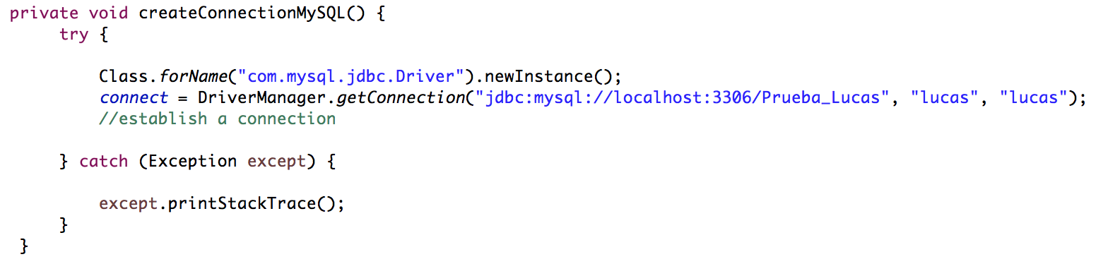

In the following screenshot the password of the user is altered to make the program crash.



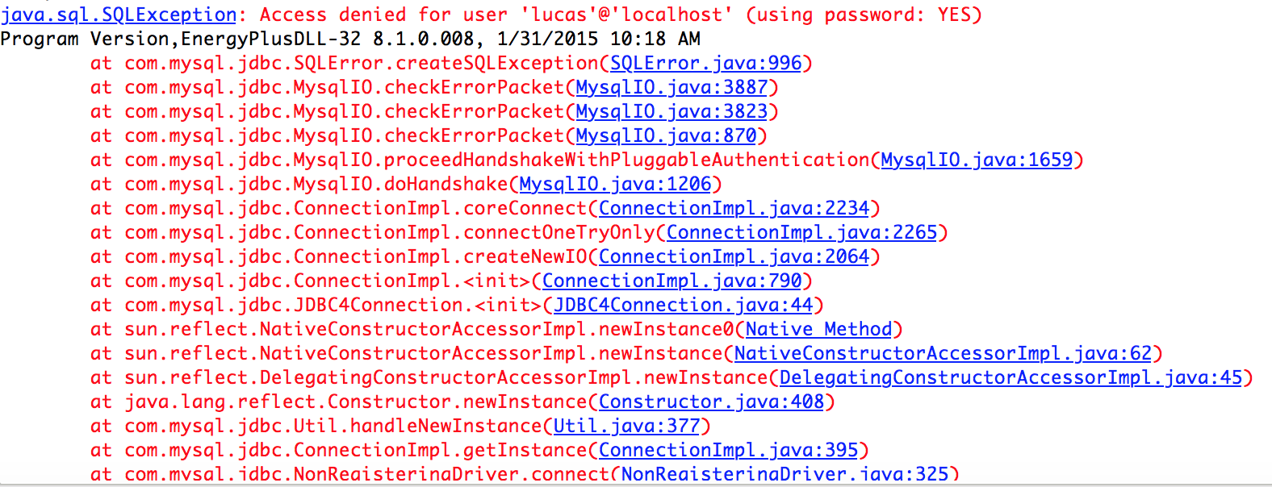

So for security reasons, only users that have the correct privileges can connect, and insert or do other SQL commands. This user is set once and then the program works with this user.

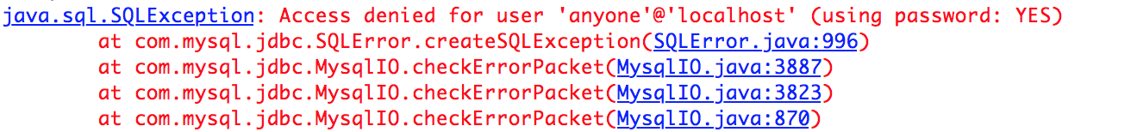I tried to do another test with a user that doesn’t exist in the database scheme, and as expected, he couldn’t connect.



* Tested the socket with different types of data, from the file we are reading or the recording from the ideal sensor.

The program as of now for functionality reasons, work with the sample file that our sponsor gave us. All the buildings can eventually output an .ESO file which a specific order that we implemented. We implemented a socket, so we could communicate from the server side program to the client. To have something in the communication, our program is moving the .ESO file through the socket, but it is designed to receive information from the sensors.

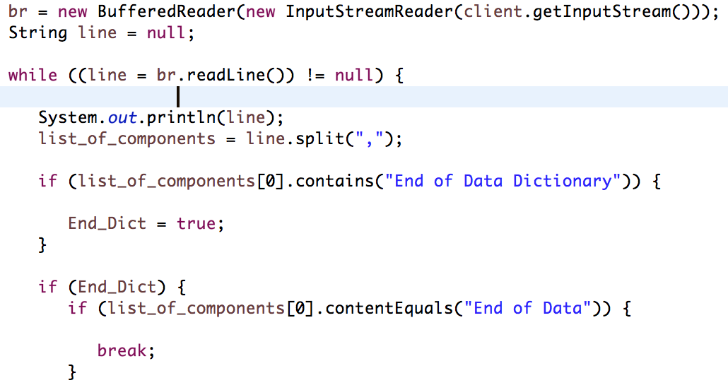

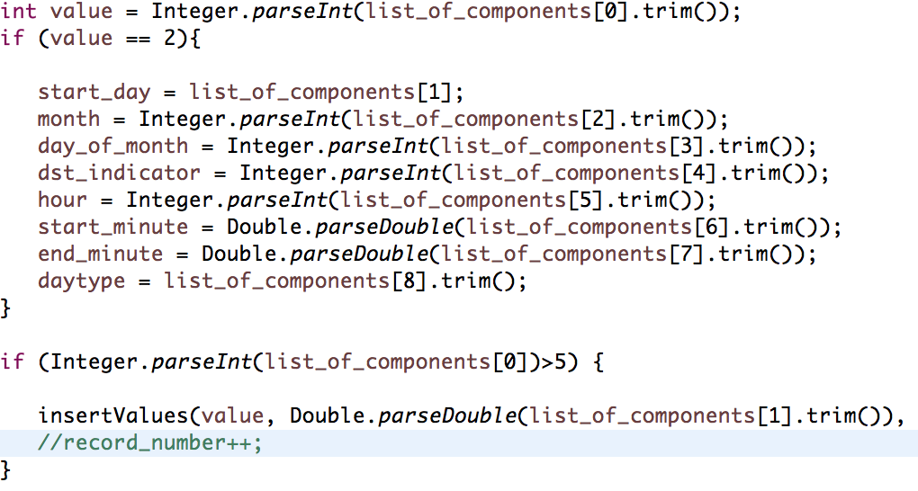In this screenshot we are creating the socket that is receiving the input stream from the client. Now I will show evidence of the structure to read the file.

So as we can see, with the correct structure, the program runs. But if we input a different type of file, it’s not going to read it. In this case the program doesn’t crash, but it doesn’t write the data into the database.

* Tested the connection between the backend/database and the front end with different values to see if the front end was successfully changes colors.

The front-end is actually reading the values from a txt file that the backend program writes to. Depending in the ideal value of each variable, the actual recording that the program writes in the file is compared and depending in the proximity, it states a green color if its close and a red if it far away. If the color is green, that variable is doing really good.

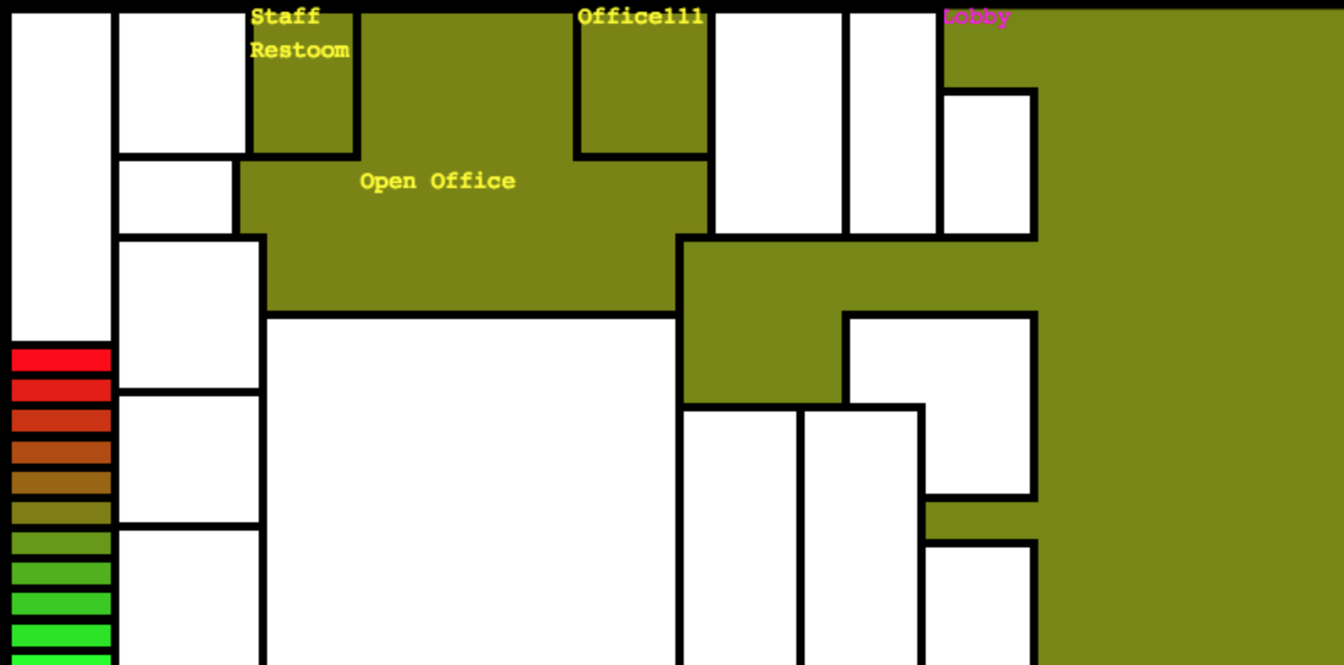

When we run the program, the initial value for the mean air temperature for this room is in the middle of green/red, it’s not doing so well, but when the hours start to go by, and the start of the day we can see the change in the color. So we could conclude that in the nights there is a drop in the temperature. 